
COMMERCIAL CATERING
GAS SAFETY INSPECTION
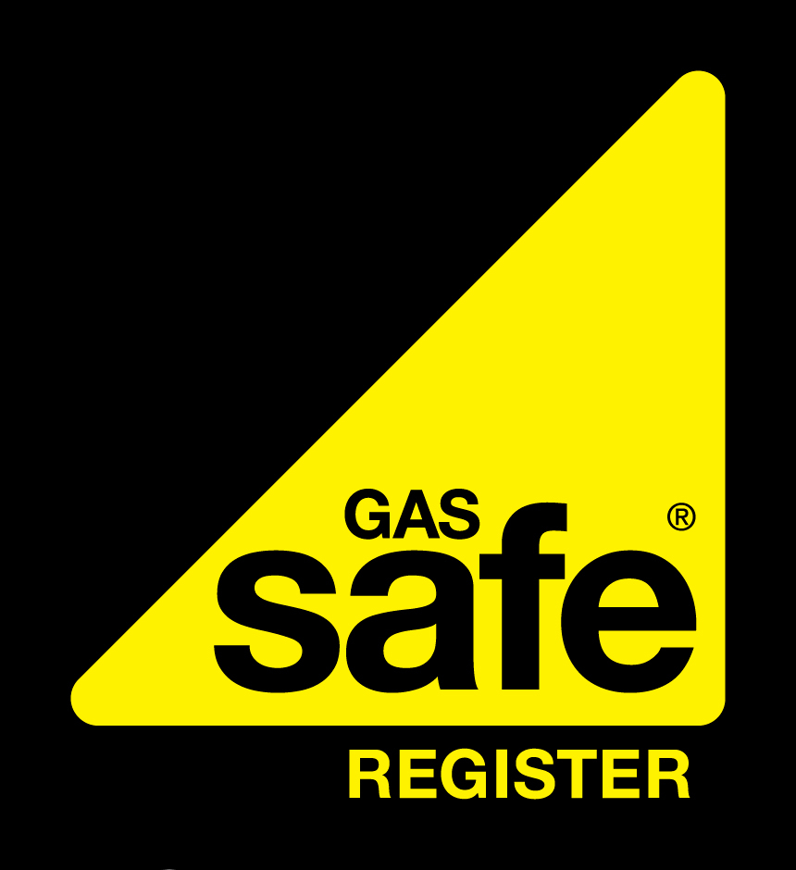
To confirm the validity of the Registered Gas Engineer please contact Gas Safe on 0800 408 5577 or www.gassaferegister.co.uk
Key Integrated Services Ltd  Gas Safe Reg No: 530254  W: www.keyis.com E: info@keyis.com  Job Number: | CLIENT DETAILS
 | Name:
 | Address:
 | Postcode:
 | Date:
VENTILATION / EXHAUST SYSTEM |  |  |  |  |  |  |  |  |  |  |  |  | GAS INSTALLATION DETAILS
Has a canopy system been installed? |  |  |  |  |  |  |  |  |  |  |  |  | ECV installed for catering area?
If yes is the canopy fixed / hanging correctly? |  |  |  |  |  |  |  |  |  |  |  |  | ECV in satisfactory location?
Type of filtration (e.g mesh / baffles / UV) |  |  |  |  |  |  |  |  |  |  |  |  | ECV accessible?
Is filtration adequately maintained? |  |  |  |  |  |  |  |  |  |  |  |  | Suitable valve type?
Is mechanical exhaust provided? |  |  |  |  |  |  |  |  |  |  |  |  | Valve handle attached?
If yes what is the flowrate? |  |  |  |  |  |  |  |  |  |  |  |  | Direction of operation shown?
Is the flowrate adequate? |  |  |  |  |  |  |  |  |  |  |  |  | Emergency notice present?
Is an exhaust / ventilation interlock provided?  Yes  No |  |  |  |  |  |  |  |  |  |  |  |  | Automatic isolation system fitted where appropriate?
If yes is the interlock working correctly?  Yes  No |  |  |  |  |  |  |  |  |  |  |  |  | Is the system fitted with automatic pressure proving?
Is satisfactory make up air provided?  Yes  No |  |  |  |  |  |  |  |  |  |  |  |  | Is there a manual reset facility?
If natural ventilation is provided is it adequate?  No |  |  |  |  |  |  |  |  |  |  |  |  | Is there a warning notice?
(Provide details) High level (cm)  Yes |  | No |  |  | Low level (cm) |  |  |  |  |  |  |  | Do appropriate appliances have full flame safeguard?
Are automatic means of CO detection provided? |  |  |  |  |  |  |  |  |  |  |  |  | PIPEWORK WITHIN THE CATERING AREA
Are automatic means of CO₂ detection provided?  Yes  No |  |  |  |  |  |  |  |  |  |  |  |  | Are correct materials being used?
Max CO₂ ppm recorded at 2m from floor level in centre of operator(s) area? |  |  | Max CO₂ ppm recorded just outside edge of extract canopy |  |  |  |  |  |  |  |  |  | Is pipework correctly identified & labelled?
 |  |  |  |  |  |  |  |  |  |  |  |  | Is pipework correctly supported?
DETAILS OF ANALYSER USED |  |  |  |  |  |  |  |  |  |  |  |  | Do sleeves extend through walls / floors?
Make : |  |  |  |  |  |  |  |  |  |  |  |  | Are purge points fitted?
Model : |  |  |  |  |  |  |  |  |  |  |  |  | Are suitable test points fitted?
Last Calibration date : |  |  |  |  |  |  |  |  |  |  |  |  | Main protective equipotential bond fitted?
RISK ANALYSIS OF KITCHEN VENTILATION SYSTEM
MECHANICAL VENTILATION
Has a risk assessment in accordance with HSE Catering Information Sheet 23 (CAIS 23) been completed?
If applicable what is the outcome of the risk assessment (Satisfactory / NCS / AR / ID)
APPLIANCES |  |  |  | 1 |  |  | 2 |  |  |  | 3 |  |  | 4 | 5 | 6 | 7 |  |  | 8
Type of appliance
Appliance make
Appliance model
Manufacturer’s instructions available
Burner pressure (mbar) or heat input ((
FSD fitted to all burners?
FSD operating correctly?
Power isolator & correct fuse fitted?
Max CO reading above appliance
Max CO₂ reading above appliance
Gas isolation valve fitted?
Gas hose & restraint fitted correctly?
Pipework gas tight?
Safe to use?
SAFETY INFORMATION
MECHANICAL VENTILATION
Has a warning advice notice been issued? (Y / N)
Have suitable warning labels been attached? (Y / N)
LIST WORK UNDERTAKEN |  |  |  |  |  |  |  |  |  |  |  | LIST REMEDIAL WORK NEEDED

Engineer | Name | Signature

